Database Design Coursework Template

Student Name:
Julie Bui

Student ID:
adgf493

Student Number:
220018065

Scenario Topic Name
National Dance Competition

Scenario (100 words maximum)

The database stores the information of a National Dance Competition. Each of the dance teams competing are recorded along with their performance, the dancers within the team, their associated dance studio and choreographer, with the results of the competition produced by the judges. The competition consists of various dance teams competing, with the team’s name, number of dancers, team description and achievements stored. Each performance is recorded with its name, level, dance style, date and time, stage, song, and description. The details of each dancer of the dance team are stored, comprising of their name, email, phone number, date of birth, address, gender, level, dance style and number of years dancing. The database also includes information of the dance studio, including its name, email, phone number and address. The results of the competition are recorded, with the winning team selected based on their rank and score, with an award and feedback given at the end. The results are based on the judges’ inputs and the details of each judge, including their name, email, phone number, date of birth, address, gender, specialty, and qualification are stored in the database.

Example queries (Minimum 5 – list, who, which, how many, most, fewest etc. - check that your models have the attributes needed to answer the queries)

What dance team has the highest score?
When is the first performance held?
How many dance teams perform at “intermediate” level?
What is the location of the dance studio of “fireflies” dance team held?
List the names of dancers that are over 18.

Entity Relationship Model (insert a jpg image of your model exported from Visual Paradigm in the space below).

Insert your jpg image here

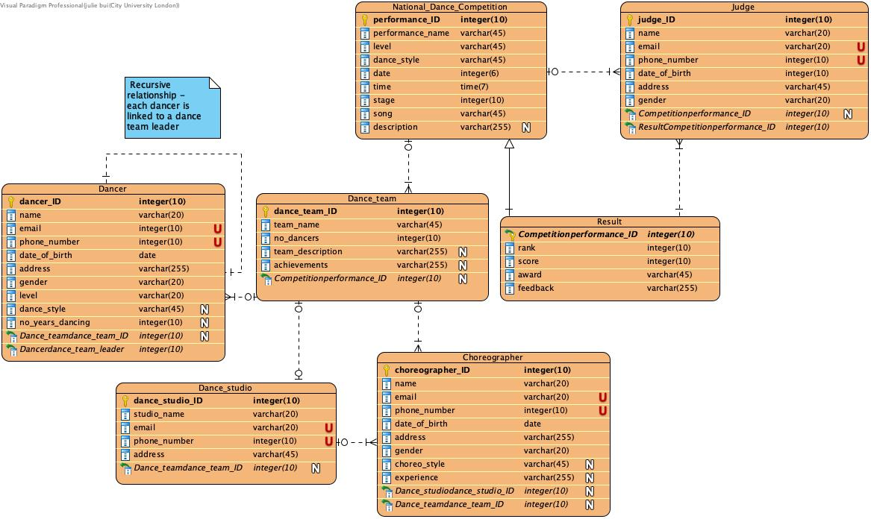

Relational Model Tables
- Copy and paste the table below for as many relational tables as you need
- Replace the placeholder names (table-name1, attribute-name5 etc) with the table and attribute names you derived from your ER model
- List primary key attributes first
- Add new rows to the tables (in the correct place) as needed
- Delete any unnecessary rows (attribute rows and foreign key rows if not used)
- Primary keys are to be specified in the format PRIMARY KEY (attribute-name1, attribute-name2, etc)
- Foreign keys are to be specified in the format ‘FOREIGN KEY (attribute-name) REFERENCES table-name (attribute-name)

Relational table specification | Marker’s corrections (Do not write in this column)
Table name: National_Dance_Competition
Attributes
performance_ID
level
dance_style
date
time
stage
song
description
PRIMARY KEY (performance_ID)

Relational table specification | Marker’s corrections (Do not write in this column)
Table name: Dance_team
Attributes
dance_team_ID
team_name
no_dancers
team_description
achievements
Competitionperformance_ID
PRIMARY KEY (dance_team_ID)
FOREIGN KEY (performance_ID) REFERENCES Competition (performance_ID)

Relational table specification | Marker’s corrections (Do not write in this column)
Table name: Dancer
Attributes
dancer_ID
name
email
phone_number
date_of_birth
address
gender
level
dance_style
no_years_dancing
Dance_teamdance_team_ID
Dancerdance_team_leader
Dancerdance_team_leader
PRIMARY KEY (dancer_ID)
FOREIGN KEY (dance_team_ID) REFERENCES Dance_team (dance_team_ID)
FOREIGN KEY (dance_team_leader) REFERENCES Dancer (dance_team_leader)

Relational table specification | Marker’s corrections (Do not write in this column)
Table name: Dance_studio
Attributes
dance_studio_ID
studio_name
email
phone_number
address
Dance_teamdance_team_ID
PRIMARY KEY (dance_studio_ID)
FOREIGN KEY (dance_team_ID) REFERENCES Dance_team (dance_team_ID)

Relational table specification | Marker’s corrections (Do not write in this column)
Table name: Choreographer
Attributes
choreographer_ID
name
email
phone_number
date_of_birth
address
gender
choreo_style
experience
Dance_studiodance_studio_ID
Dance_teamdance_team_ID
PRIMARY KEY (choreographer_ID)
FOREIGN KEY (dance_studio_ID) REFERENCES Dance_studio (dance_studio_ID)
FOREIGN KEY (dance_team_ID) REFERENCES Dance_team (dance_team_ID)

Relational table specification | Marker’s corrections (Do not write in this column)
Table name: Judge
Attributes
judge_ID
name
email
phone_number
date_of_birth
address
gender
Competitionperformance_ID
ResultCompetitionperformance_ID
PRIMARY KEY (judge_ID)
FOREIGN KEY (performance_ID) REFERENCES Competition (performance_ID)
FOREIGN KEY (performance_ID) REFERENCES Result (performance_ID)

Relational table specification | Marker’s corrections (Do not write in this column)
Table name: Result
Attributes
Competitionperformance_ID
rank
score
award
feedback
PRIMARY KEY (performance_ID) REFERENCES Competition (performance_ID)
FOREIGN KEY(performance_ID) REFERENCES Competition (performance_ID)

Marker’s Comments (Do not write in this section)

Scenario

Your scenario is not a generic database scenario but has been tailored to your interests. You describe your entities, attributes and relationships in detail but you could improve the clarity of explanation for some of your relationships.

Queries

Your queries can be addressed by an implementation of your ERD.

ERD

Your dancer and dance team entities are reasonable as is your use of recursion to model team leadership. Your Dance_studio entity is sensible but you related to dance team using a one to one relationship which implies that a studio has only one team. The reason for this restriction is not made clear in the scenario. A dance team has many choreographers but a choreographer can only work with one dance team based on your relationship definition - this restriction is not explained in your scenario.

You have added a sub type Result that does not have an IS-A relationship with the supertype (Competition) and the inheritance relationship is not labelled.

The competition entity appears to record performances. The reason for calling it National_Dance_Competion instead of Performance is not clear from your scenario. The constraint that one performance has many teams suggests that a team only performs once, which in turn implies that only one record is required for the National_Dance_Competion table - the nature of the model could be clarified in the scenario. You specify a judge produces a single result which is a summary of the collaboration of many judges. The reason a judge cannot produce a result for a different performance is not clear.

Relational model

You have correctly mapped the entities to corresponding relations.

Coursework Mark (100 marks available): 61.6

